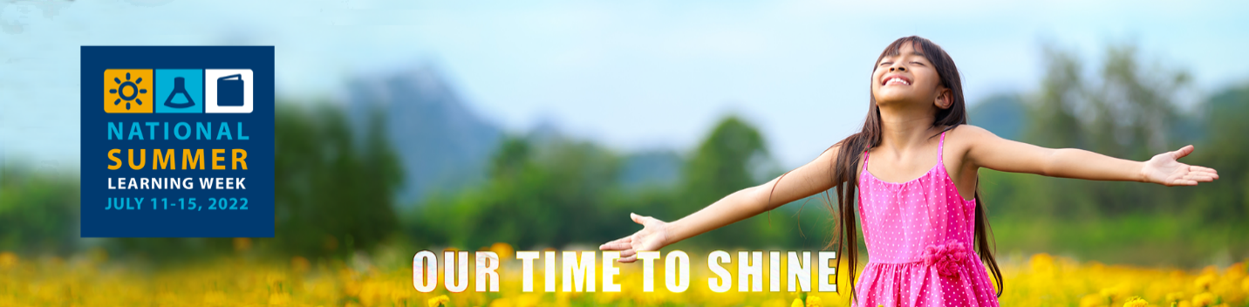

Summer Learning Week July 11-15, 2022
The National Summer Learning Association (NSLA) is a national, non-profit organization focused on the powerful impact of one achievable goal: investing in summer learning to help close the achievement gap. NSLA uses the power of research, advocacy, training, and policy to transform America’s neighborhoods and communities, one child at a time. Their work is based on the simple idea that summer—a time that is easily overlooked yet critical to educational development—is bursting with possibility, and instrumental in closing the achievement gap between privileged children and less-resourced children. By casting a spotlight on summer learning loss, and galvanizing parents, educators, legislators, and community organizations to embrace the power of summer learning, NSLA hopes to create a space for greater achievement and potential for all children.
National Summer Learning Week is a celebration committed to promoting the significance of keeping kids learning, safe, and healthy throughout the summer so they can be ready to tackle the next school year. Summer Learning Week 2022 has daily themes and CASE for Kids has created activities, SMART Zone resources and challenges for each day.
Fostering Friendships:
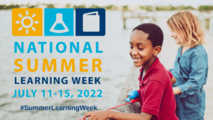
The pandemic’s impact on youth has been startling, and the U.S. Surgeon General has raised a flag on young people’s mental health. The science of learning and development tells us that relationships are key for addressing trauma and helping kids thrive. Forging and fostering friendships over the summer can lead to limitless opportunities and cherished memories for young people.
Activity: Create Your Own Board game
Board games are a great way to create a fun and informal way for youth to make friends and create social connections. The foundation of board game playing is cooperation. This requires youth to engage in teamwork, practice their verbal communication skills, teaches creativity and self-confidence, self-regulation, by waiting your turn as well as many other benefits. Board games are just a fun way to make and spend time with new friends.
Resource: CASE for Kids is proud to offer Harris County OST programs the ability to access a variety of materials, through the SMART (Sharing Multiple Afterschool Resources and Technology) Zone. This free lending library offers a variety of educational board games that teach numeracy and literacy concepts in a fun, competitive way. Contact Kathy Evans at kevans@hcde-texas to schedule a visit.
Challenge: Share your student’s playable board game with us for a chance to win a free boardgame for your site. Search online for free board game templates students can use. Some templates are listed below, but there are many templates available. Encourage youth to be creative with their board game designs. Make sure that your students have media releases if you feature them in photos. Email photos to kevans@hcde-texas.org to be featured on our website and be eligible to win free board games. Be sure to tag us in social media posts using our handle: @HCDE_CASE.

Links:
• http://people.uncw.edu/ertzbergerj/word_games.html
• https://www.pbs.org/parents/crafts-and-experiments/create-your-own-board-game

Love of Literacy & Learning:

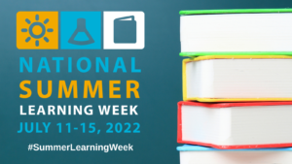
Reading is fun! It’s also critical to a child’s success in school, and in life. Empower children to immerse themselves in a literary adventure. It can take place anywhere, under a tree, in a makeshift tent, or in a child’s favorite nook. Let imaginations run wild with amazing stories this summer.

Activity: Work on student’s sense of drama this week! Reading is necessary for learning, so instilling a love of reading at an early age is the key that unlocks the door to lifelong learning. Instilling a love of reading early gives a child a head start on expanding their vocabulary and building independence and self-confidence. It helps children learn to make sense not only of the world around them but also people, building social-emotional skills and of course, imagination. Students will enjoy hearing famous actors read some of their favorite stories at storylineonline. Checkout the Reader’s Theater sets from the SMARTZone to help get your kids ready to create book magic, or borrow our video equipment for your students to record their movie.

Resource: CASE for Kids is proud to offer Harris County OST programs the ability to access a variety of materials, through the SMART (Sharing Multiple Afterschool Resources and Technology) Zone. This free lending library offers Readers Theater guides for all age ranges! Encourage students to build their reading fluency and be dramatic this summer. You can also borrow video cameras, microphones and other podcast materials to help in the challenge. Contact Kathy Evans at kevans@hcde-texas to schedule a visit.

Adult Challenge: Reading is a life-long pleasure and it is important to share that message with students and others. Help CASE staff and others in the OST community find great books this summer! Complete this book challenge list and share with CASE via kevans@hcde-texas.org .

Challenge: Create a 90 second book video based off a Newbery Medal, or Honor book. Visit the website to learn more about this exciting contest. Share your students’ book video with CASE by emailing it to kevans@hcde-texas.org . Prizes for participation will be offered.

Links:
• https://storylineonline.net/
• https://www.freechildrenstories.com/
https://txla.org/news/2021-2022-texas-bluebonnet-award-master-list-released/

Wonders of Wellness: Get Fit
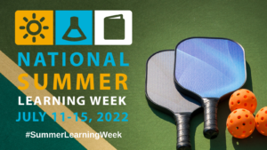
Get physically fit, by engaging in some fun exercises or by trying something new, like yoga. Physical activites can help youth improve their cardorespiratory fitness, build strong bones and muscles, control weight, reduce sympotms of anxiety and depression and reduce the risk of developing health conditions. Higher physical activity and physical fitness levels are associated with improved cognitive performance (e.g., concentration, memory) among youth.

Activity: Outdoor play can be difficult under the hot sun of Houston. Students need fresh air but you can also help them stay active indoors, with great ideas from Fitboost and Fitflow from Sandford Harmony. These quick actvities can get heart rates up or just give kids an opportunity to strech it out. Been awhile since you played some of these sports and need to brush up on techniques? Fitsports from Sandford Harmony can help with articles and videos about sports.

Resource: CASE for Kids is proud to offer Harris County OST programs the ability to access a variety of materials, through the SMART (Sharing Multiple Afterschool Resources and Technology) Zone. This free lending library offers many pieces of sports equipment such as complete tennis setups, fencing equipment, soccer balls and other sports paraphernalia. Contact Kathy Evans at kevans@hcde-texas to schedule a visit.

Challenge: How fit are you and your students? Can you skip rope for a count of 50? How about a count of 100? Share a video of your students skipping rope, either individually or as a team, doing some jumping rope skill, like Double Dutch. Make sure if student faces are visible that you have media releases for each. Win sports equipment for your program by participating.

Links:
- https://fit.sanfordhealth.org/
- https://namastekid.com/tool-type/kids-yoga-poses/

Summer Skill Building: Learn something new
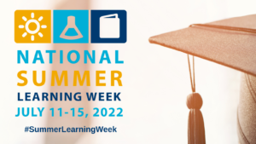
Everybody has their own unique skill set which can make them reach heights if explored correctly. Skill development is considered relevant for students because it can prepare them for success in and out of school. Examples of such skills can include communication and technical skills. People with such skills are in high demand on the job market and are also in position to earn more. Since skill development is a process that includes identifying skill gaps, developing, and honing these skills is crucial to student success.

Activity: Celebrate the hot Houston sun and help students build their STEM skills this summer. Students can create solar print fabric, cook s’mores in a solar oven, and create suncatchers and prisms.
Resource: CASE for Kids is proud to offer Harris County OST programs the ability to access a variety of materials, through the SMART (Sharing Multiple Afterschool Resources and Technology) Zone. This free lending library offers many STEM experiences for students to build their skills. Solar cars kits, coding equipment and more are all available. Contact Kathy Evans at kevans@hcde-texas to schedule a visit.

Challenge: How are you challenging your students this summer? Do you want to help students develop their music skills? SMART Zone has ukuleles, drums, sheet music and more to create a summer band. Share a performance with CASE for Kids or send in some of your solar experiments! Email kevans@hcde-texas.or g and be entered to win solar cars.

Links:
- Design Squad: Invent it, Build It: Making the world a better place - Research tells us that when kids think their activity helps others it increases engagement. Activities encourage kids to think of themselves as inventors, discuss inventing and engineering, and dispels the stereotype that engineering is boring.

- 8 Best Invention Ideas for Children - Try some fun and silly inventions that are very engaging: These activities are free, easy to set up, and use materials familiar to kids.
- 17 Innovative Mathematics Projects that Inspire Students - A list of some unique, hands-off, and fun mathematical projects for any blooming mathematician.

Amazing Arts: Upcycling

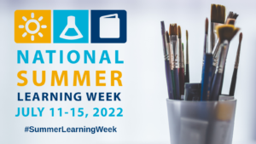
Engaging with art is essential to the human experience. Almost as soon as motor skills are developed, children communicate through artistic expression. The arts challenge us with different points of view, compel us to empathize with “others,” and give us the opportunity to reflect on the human condition. Through the arts, students develop skills like resilience, grit, and a growth mindset to help them master their craft, do well academically, and succeed in life after high school.

Activity: Summer is a great time to undertake a larger art project with multiple steps. Kids can design a sidewalk chalk mural and then create it. Or see if you can create a more permanent art piece. The sky is the limit when it comes to summer art!

Resource: CASE for Kids is proud to offer Harris County OST programs the ability to access a variety of materials, through the SMART (Sharing Multiple Afterschool Resources and Technology) Zone. This free lending library offers many items to encourage your student’s creativity, including comic book curriculum. Contact Kathy Evans at kevans@hcde-texas to schedule a visit.

Challenge: Did you know that you can create beautiful pieces of art using recycled materials? You can by upcycling. Upcycling is the practice reusing and recycling found objects to create new works of art. Using the any old, and recycle material as create a work of art. Visual and plan how you can reclaim that empty water bottle, cardboard box, bottle cap, or old newspaper. What type of art will you create? Don’t forget to share your masterpiece with us. Email your projects to kevans@hcde-texas.org to win a prize.

Links:
- https://www.youtube.com/watch?v=OsfG7i8Lyf8
- https://www.doodlecraftblog.com/2019/08/upcycled-rolled-paper-frame-diy-craft.html

